**Missing ICORE PVC ID in EFMS**

1. Check for the USRP order # in TT, else ask user/EFMS to provide it.
2. Find the PVC activity_id and check for the transaction_type=49 in load_external_system.

**select * from load_external_system where transaction_key=18370260 and transaction_type=49**

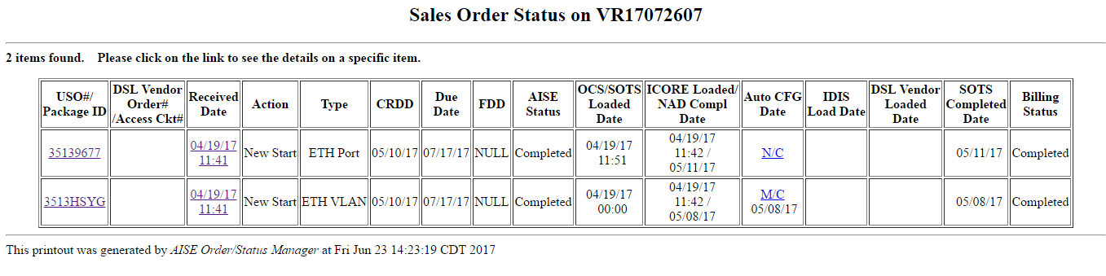

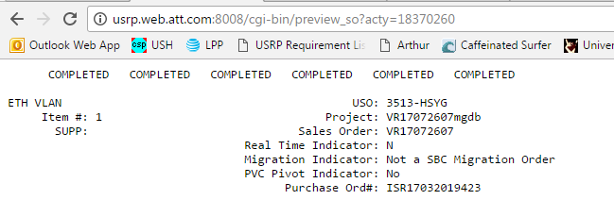

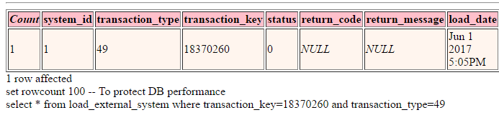

**To retrigger ICORE PVC ID TO EFMS**

update load_external_system set status=null,load_date=null where transaction_key=18370260 and transaction_type=49

Ask EFMS to check for ICORE PVC ID in EFMS DB after an hourly cron.